“ Providing expert QHSE solutions throughout Industry”

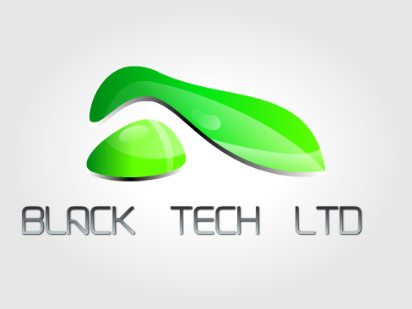

Black Technologies Limited is a company that strives itself in helping businesses to develop their Quality management systems. Be it Quality, Health and Safety or Environmental – Black Tech can help!

The company has vast experience with QMS and will match your business needs from ISO 9001,14001 and 18001 to AS9100 and TS16949 standards it will succeed and surpass your expectations.

Black Technologies Limited can also offer you:
Internal and Supplier Audits
NPI techniques and advice
New Plant build and capital investment
Continuous Improvement
Risk assessment and Method Statements
COSHH assessments
For more information or a quotation on the services we offer please contact: Tom Langford
Director
Tel: 07486530054
Email: blacktechltd@outlook.com
